
PLANNING AND ZONING BOARD STAFF REPORT
November 6, 2024, Planning and Zoning Board Meeting

Southern Grove-SLC Fire Station No. 20-Cell Tower
Special Exception Use
P24-119

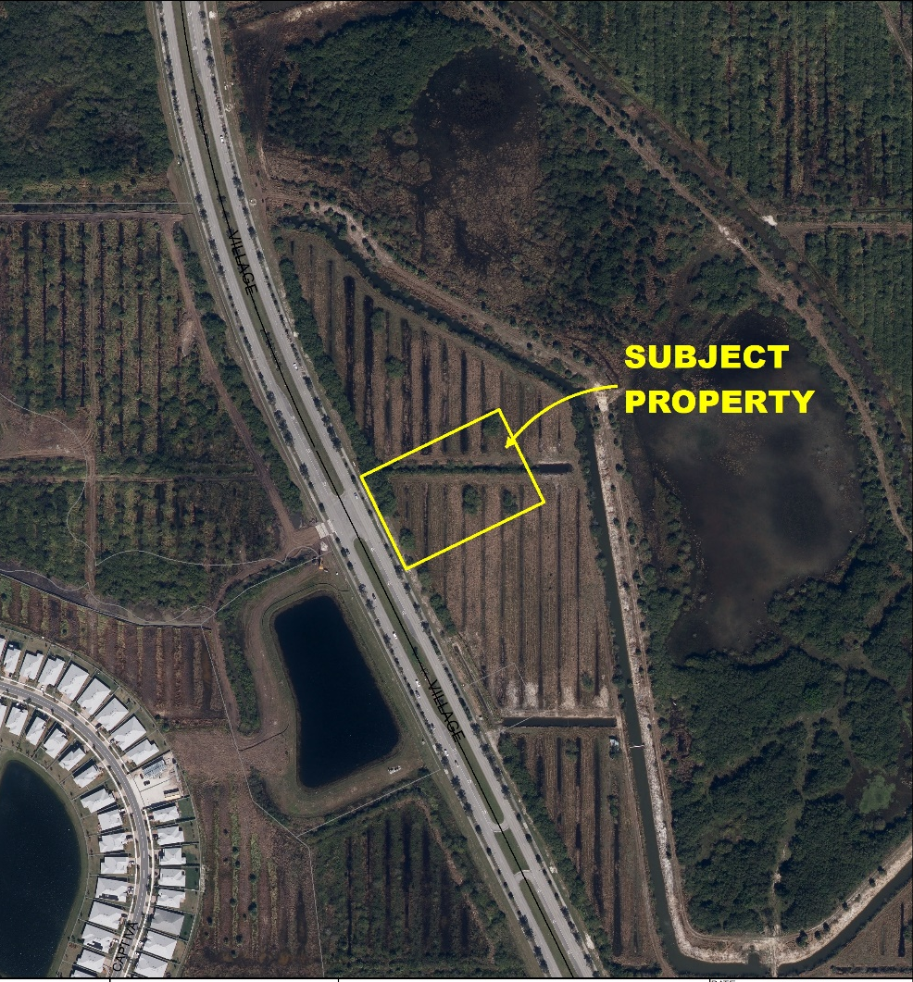
Project Location Map

SUMMARY
Applicant’s Request: | The request is for approval of a Special Exception Use (SEU) to allow a 150-foot-tall monopole tower in the Master Planned Unit Development (MPUD) Zoning District, within the Business Park land use designation, per Section 5.2.1(C)(1) of the Tradition Commerce Park North at Southern Grove MPUD Regulation Book and Section 158.214 of the Zoning Code.
Agent: | Vlada Peterka, Redtail Design Group, Inc.
Applicant/Property Owner: | St. Lucie County Fire District
Location: | 12440 SW Village Parkway
Project Planner: | Francis Forman, Planner II
Project Description
The City of Port St. Lucie has received a request from Vlada Peterka with Redtail Design Group, Inc., acting as agent for the St. Lucie County Fire District, for a special exception to allow a 150-foot-tall monopole tower in the Master Planned Unit Development (MPUD) Zoning District, within the Business Park land use designation, per Section 5.2.1(C)(1) of the Destination at Tradition MPUD Regulation Book and Section 158.214 of the Zoning Code. The approximately 2.50-acre property is located on the east side of SW Village Parkway, and north of SW Marshall Parkway. The property’s address is 12440 SW Village Parkway, and the legal description is Southern Grove Plat No. 40 Parcel 2.

The proposed monopole tower is intended to address a significant gap in cellphone coverage in the Southern Grove and Tradition areas. The tower will accommodate up to four (4) service carriers and enhance connectivity in the vicinity. The site will be developed with the St. Lucie County Fire Station No. 20 facility, which was approved at the November 13, 2023, City Council meeting. The conceptual plan depicts the 150’ monopole and accompanying equipment within a 50 foot by 50 foot (2,500 S.F.) rectangular lease area at the northeast corner of the property.

The tower shall be designed by a licensed Florida State Professional Engineer meeting the respective building code criteria. The tower shall be designed and constructed such that in the event of a tower failure the tower shall collapse upon itself with a resultant tower fall zone radius which will be entirely on the leased tower area. The tower will resemble a light pole with the array located at the top, minimizing visual impact.

Previous Actions
The City of Port St. Lucie Site Plan Review Committee (SPRC) reviewed and recommended approval of the conceptual site plan at their August 28, 2024, meeting.

Public Notice Requirements
Notice of this request for a Special Exception Use was mailed on October 25, 2024, to owners of property within a 750-foot radius of the subject property.

Location and Site Information
Parcel Number: | 4315-804-0004-000-5
Property Size: | 2.50 acres
Legal Description: | SOUTHERN GROVE PLAT NO. 40, Parcel 2 (Plat Book 102, Page 39)
Future Land Use: | NCD (New Community Development)
Existing Zoning: | MPUD (Master Planned Unit Development)
Existing Use: | Vacant

Surrounding Uses
Direction | Future Land Use | Zoning | Existing Use
North | NCD | MPUD | Vacant
South | NCD | MPUD | Vacant
East | NCD | MPUD | Vacant
West | NCD | MPUD | Vacant
NCD - New Community Development District
MPUD - Master Planned Unit Development

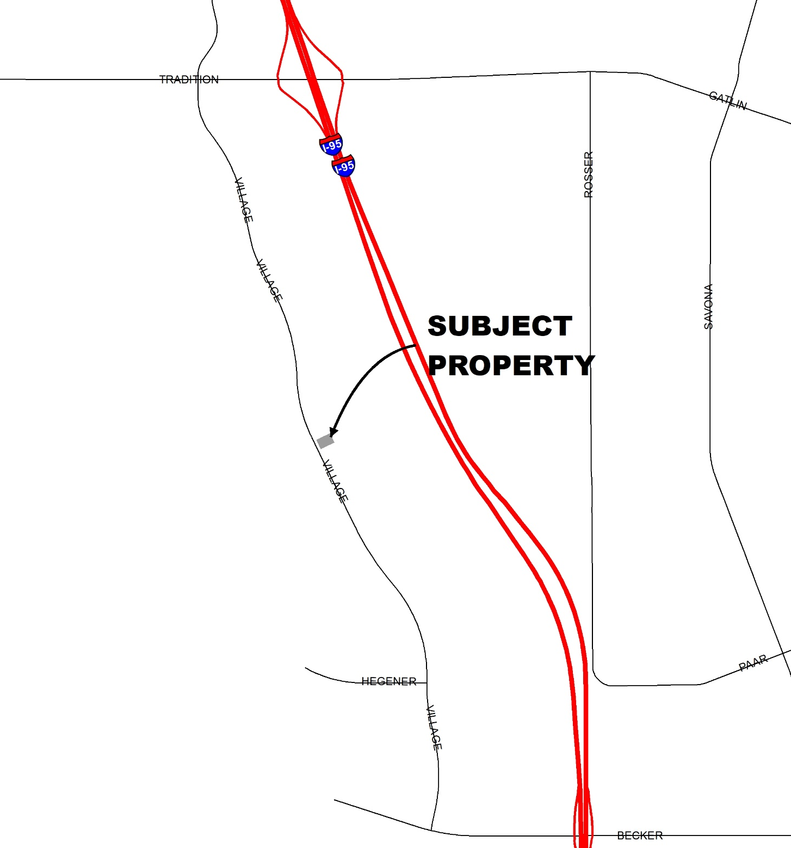
Location Map
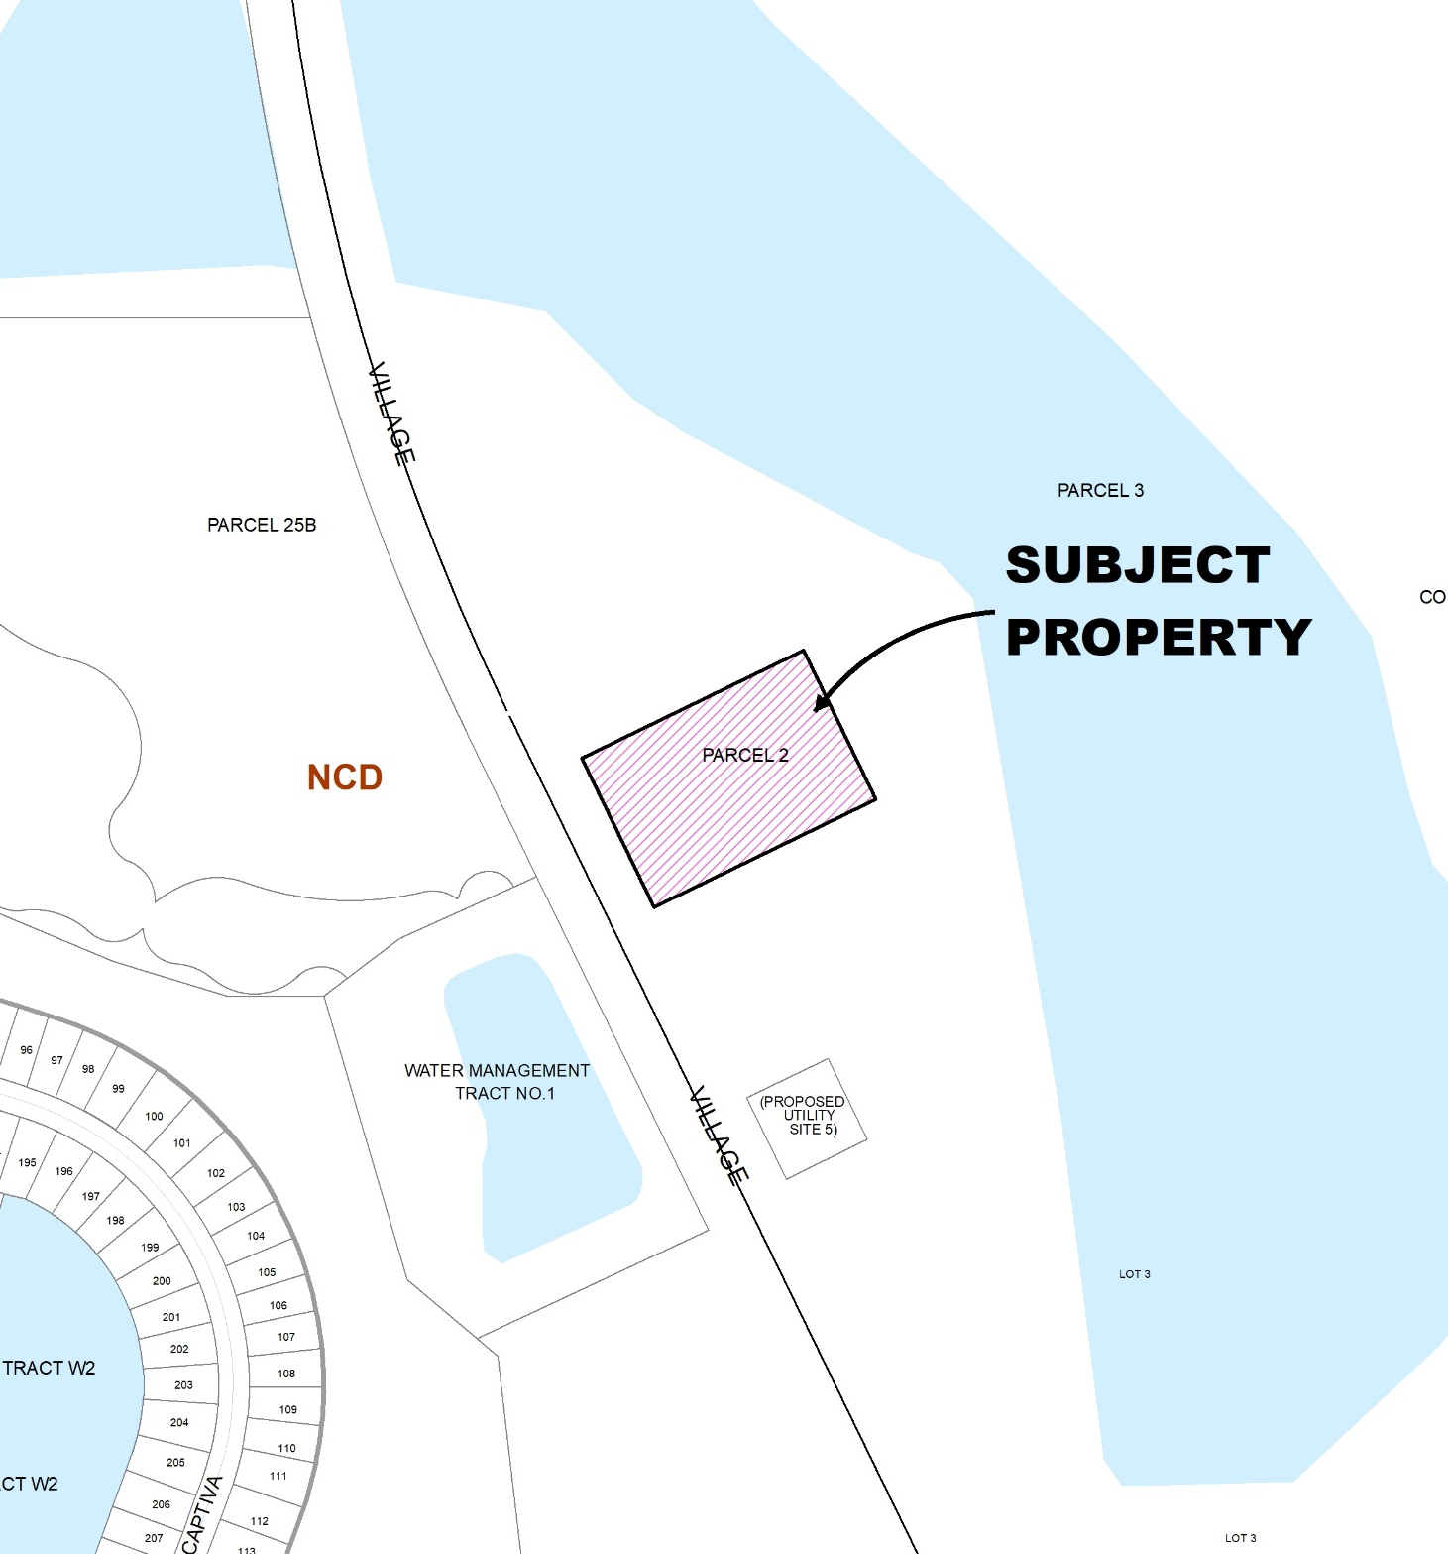
Land Use Map

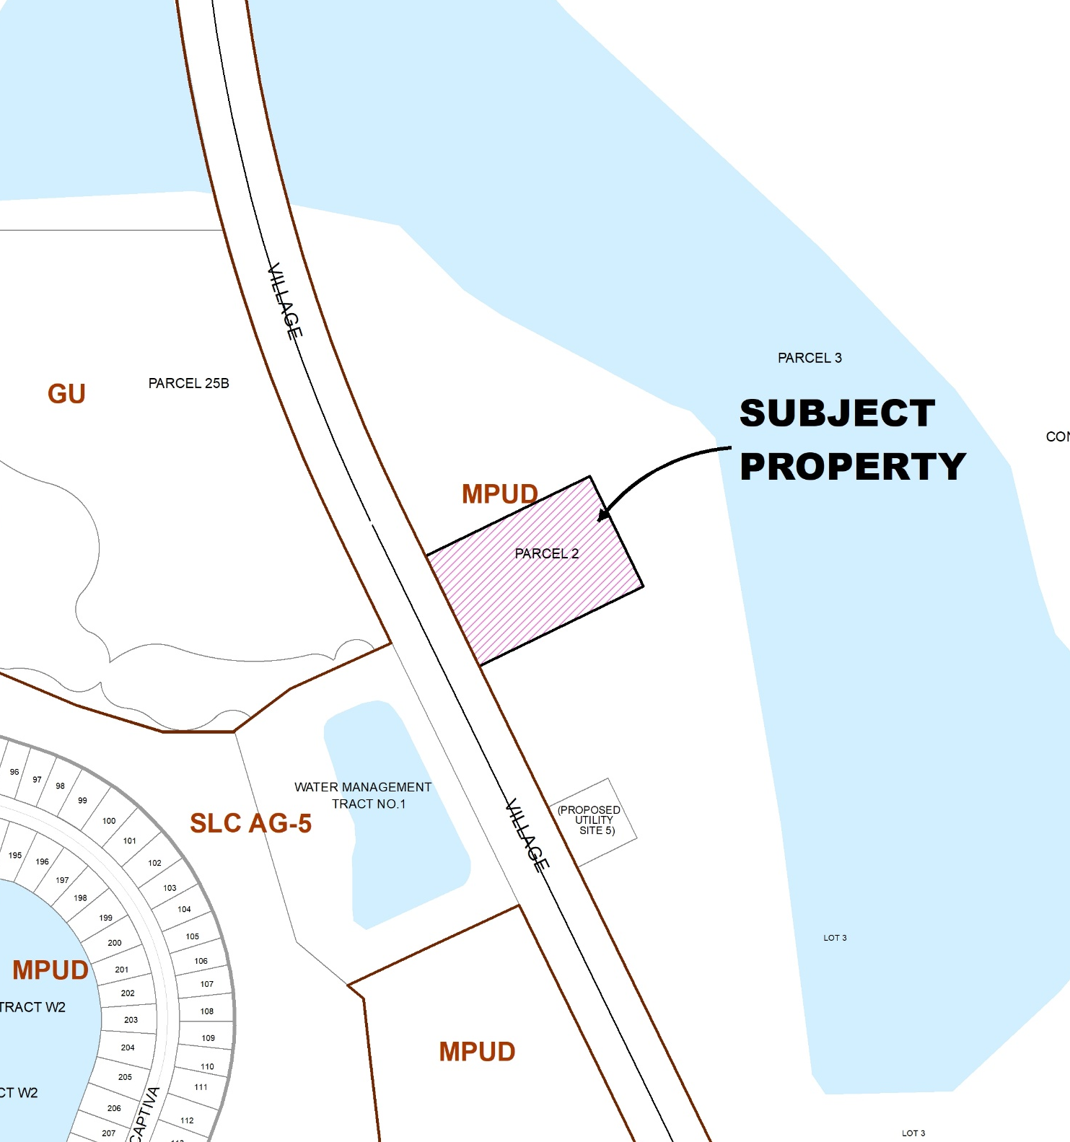
Zoning Map

PROJECT ANALYSIS
Special exceptions are uses that would only be allowed under certain conditions and are reviewed to be compatible with the existing neighborhood. Approval of a special exception application shall only be granted by the City Council if it meets the criteria established under Section 158.260 (A) through (L) as noted below. The applicant’s response to the criteria is attached. Staff’s review is provided below.
Evaluation of Special Exception Criteria (Section 158.260)
(A) Adequate ingress and egress may be obtained to and from the property, with particular reference to automotive and pedestrian safety and convenience, traffic flow and control, and access in case of fire or other emergency.
- Applicant’s Response: The proposed special exception use is to allow for a monopole tower on the subject parcel that has vehicular access to the tower by authorized personnel for maintenance and operation purposes. The proposed use will not increase traffic and will impact adjacent roadways.
- Staff findings: Adequate ingress and egress exists. The site's established access driveways provide convenient entry and exit points for vehicles, ensuring smooth traffic flow. This pre-existing infrastructure minimizes the need for additional construction or modifications to accommodate the tower.
(B) Adequate off-street parking and loading areas may be provided, without creating undue noise, glare, odor, or other detrimental effects upon adjoining properties.
- Applicant’s Response: The proposed use will not require additional off-street parking and an 18’ x 26’ loading space is proposed in front of the cell tower. It will not create undue noise, glare, odor or other detrimental effects upon adjacent properties.
- Staff findings: The existing site plan already provides sufficient off-street parking spaces to accommodate the needs of the developing fire station site. Concurrently, a site plan amendment has been submitted to address the specific requirements associated with the proposed tower. The amendment identifies the precise location for the tower within the property and includes provisions for the addition of one loading space dedicated to tower maintenance workers. The proposed site plan amendment does not involve any changes to the existing parking spaces allocated for customers or staff visiting the fire station facility.
(C) Adequate and properly located utilities are available or may be reasonably provided to serve the proposed development.
- Applicant’s Response: The proposed use will require electric service only. No additional utilities will be required to service the proposed tower.
- Staff findings: The fire station facility is served by the Port St. Lucie Utility Services Department. Water and utility service will not be required for the proposed tower. FPL will be the provider of electricity service for the tower and compound.
(D) Adequate screening or buffering. Additional buffering beyond that which is required by the code may be required in order to protect and provide compatibility with adjoining properties.
- Applicant’s Response: The submitted site plan and landscape plan show the 8’ tall white vinyl fence that is landscaped on the outside with 9 Crape Myrtles, and continuous bush and decorative landscaping. Staff findings: No additional buffering is required. The site’s approved landscape plan provides adequate perimeter landscaping.
- Staff findings: Section 158.214 of the Zoning Code mandates certain requirements for any wireless communication antennas and towers construction. Among these requirements is adequate buffering, distance, and screening to adjacent uses to ensure proper compatibility with the overall area. The proposed wireless communications tower meets the requirements of this section by providing adequate screening and buffering to the St. Lucie County Fire Station on site and to any future uses within this portion of the Tradition Commerce Park North at Southern Grove PUD.
(E) Signs, if any, and proposed exterior lighting will be so designed and arranged so as to promote traffic safety and to eliminate or minimize any undue glare, incompatibility, or disharmony with adjoining properties. Light shields or other screening devices may be required.
- Applicant’s Response: The proposed monopole tower will not require illuminated lights that would impair or harm adjacent properties or traffic. There is no lighting or signage proposed for this project.

- Staff findings: The applicant has stated that no lighting or signage are proposed other than emergency notification signage.

(F) Yards and open spaces will be adequate to properly serve the proposed development and to ensure compatibility with adjoining properties to eliminate or minimize any undue glare.
- Applicant’s Response: The proposed area, as shown on the site plan is not interfering with any setbacks, landscape buffers or any easements.
- Staff findings: The MPUD requires a 25-foot front yard setback and 10-foot side and rear yards. The designated area for the tower is a fenced-in rectangular portion of the St. Lucie County Fire Station No. 20 parcel measuring 50 feet by 50 feet, situated at the northeast corner of the property exceeding the required 25- and 10-foot setbacks.
(G) The use as proposed will be in conformance with all stated provisions and requirements of this chapter.
- Applicant’s Response: The proposed use is allowed as a SEU in the existing zoning district. The applicant demonstrated consistency with the requirement of the City's Land Development Code by completion of the SEU and Site Plan applications.
- Staff findings: The proposed use is allowed as a special exception use in the zoning district and subarea.
Section 158.214 of the Zoning Code provides the requirements for wireless communication towers as documented below:
  - Section 158.214(E) Wind Load: The applicant has provided certification from a Florida-registered professional engineer that the tower would collapse within the designed and specified fall radius depicted on the plan and that the tower shown in the plan can withstand winds of Category 3 hurricane intensity.
  - Section 158.214(F) Height Limits: The maximum height for a wireless communications tower in the Business Park Area is 300 feet. The proposed tower will have a maximum height of 150 feet.
  - Section 158.214(G) Co-Location: The feasibility of co-location for service provision in this area is limited. Existing towers are situated at a considerable distance and would not provide reliable coverage due to the significant gap between them.
  - Section 158.214(H) Fencing: A six-foot fence with a gate around the tower and outside structures is required. An eight-foot fence is proposed as depicted on the SEU concept plan and proposed site plan amendment.
  - Section 158.214(I) Landscaping: The MPUD requires all landscaping to adhere to Chapter 154 of the City of Port St. Lucie Code of Ordinances. The Fire Station site has an approved landscaping plan that will provide substantial landscaping and buffering to any surrounding uses. This provides a sufficiently sized footprint for the tower infrastructure while ensuring appropriate separation from other site uses. The conceptual plan depicts an 8-foot-high vinyl fence and associated landscaping around the leased area.
  - Section 158.214(L) Site Plan Review: A site plan (P23-117-A1) was submitted in association with the application for a special exception use.
  - Section 158.214(M) Obsolete and Unused Towers: A removal bond or irrevocable letter of credit in the amount of $15,000 shall be required prior to obtaining final site development permits.
  - Section 158.214(N) Separation: –The applicant has submitted a map that shows the nearest towers are 1.6 and 1.9 miles apart.
  - Section 158.214(O) Interference (Bleed Over). As a condition of approval, any proposed tower or antennae shall not cause interference with the use of radio, television, or telephone broadcasting and reception. This condition has been included as part of this application.

(H) Establishment and operation of the proposed use upon the particular property involved will not impair the health, safety, welfare, or convenience of residents and workers in the City.
- Applicant’s Response: The proposed tower does not create increased traffic, noise and health issues. Due to this, there will be no safety, welfare or convenience concerns by the approval of this to residents and the workers in the City.
- Staff findings: By adhering to City Code and regulations, the establishment and operation of the proposed uses are not anticipated to impair the health, safety, or convenience of residents and workers in the City. The only traffic in the area is generated by employees and patrons of the existing car wash facility.
(I) The proposed use will not constitute a nuisance or hazard because of the number of persons who will attend or use the facility, or because of the hours of operation, or because of vehicular movement, noise, fume generation, or type of physical activity.
- Applicant’s Response: The request is for the approval of a monopole tower as a special exception to this zoning district. There are no proposed structures as part of this request so no hours of operations exist and increased traffic, noise or fumes will not be present.

- Staff findings: The request is to allow for an unmanned wireless communications tower. The traffic generated by the tower will be for maintenance and repairs only and will not constitute a nuisance or hazard.
(J) The use as proposed for development will be compatible with the existing or permitted uses of adjacent property. The proximity or separation and potential impact of the proposed use (including size and height of buildings, access location, light and noise) on nearby property will be considered in the submittal and analysis of the request. The City may request project design changes or changes to the proposed use to mitigate the impacts upon adjacent properties and the neighborhood.
- Applicant’s Response: This approximately 2.50-acre parcel has an MPUD zoning designation. Within this designation, wireless communication antennas and towers are allowed as a special exception use. As previously stated, there will be no noise, fumes or lights associated with this use.
- Staff findings: The proposed tower has been designed to ensure compatibility with existing or uses of adjacent properties. Complying with zoning regulations, the tower's design minimizes visual impact through planned placement considerations. Proximity to residential areas has been addressed with appropriate setbacks and landscaping buffers. The access location has been planned to minimize disruption to the existing car wash facility. Also, the fall radius for the proposed tower is within the boundary of the property.
(K) As an alternative to reducing the scale and/or magnitude of the project as stipulated in criteria (J) above, the City may deny the request for the proposed use if the use is considered incompatible, too intensive or intrusive upon the nearby area and would result in excessive disturbance or nuisance from the use altering the character of the neighborhood.
- Applicant’s Response: Acknowledged.
- Staff findings: Acknowledged.
(L) Development and operation of the proposed use will be in full compliance with any additional conditions and safeguards which the City Council may prescribe, including but not limited to reasonable time limit within which the action for which special approval is requested shall be begun or completed or both.
- Applicant’s Response: Acknowledged.
- Staff findings: Acknowledged.
PLANNING AND ZONING BOARD ACTION OPTIONS

If the board finds that the special exception use application is consistent with the criteria as listed in Section 158.260 (A) through (L) of the City code, then the Board may make a:
- Motion to recommend approval to the City Council with the following conditions of approval.

- Interference as a result of any approved tower or antennae shall be considered a violation of the special exception approving the tower and may result in the revocation of the special exception. Such interference may further be considered a public nuisance, and the city may order abatement of the same, including but not limited to requiring removal of the tower.
- Any obsolete or unused tower shall be removed after twelve (12) months of non-use. A removal bond or irrevocable letter of credit equal to Fifteen thousand dollars ($15,000.00) shall be required prior to obtaining final site development permits.
- Motion to amend the recommendation and recommend approval to the City Council
If the board finds that the special exception use application is inconsistent with the criteria as listed in Section 158.260 (A) through (L) of the City code, then the Board may make a:
- Motion to recommend denial to the City Council
Should the Board need further clarification or information from either the applicant and/or staff, it may exercise the right to table or continue the hearing or review to a future meeting.

