
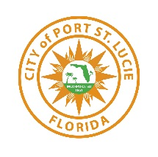
CITY COUNCIL STAFF REPORT
January 13, 2025 City Council Meeting

Riverland Parcel D - Plat Seven
Preliminary and Final Plat
P23-190
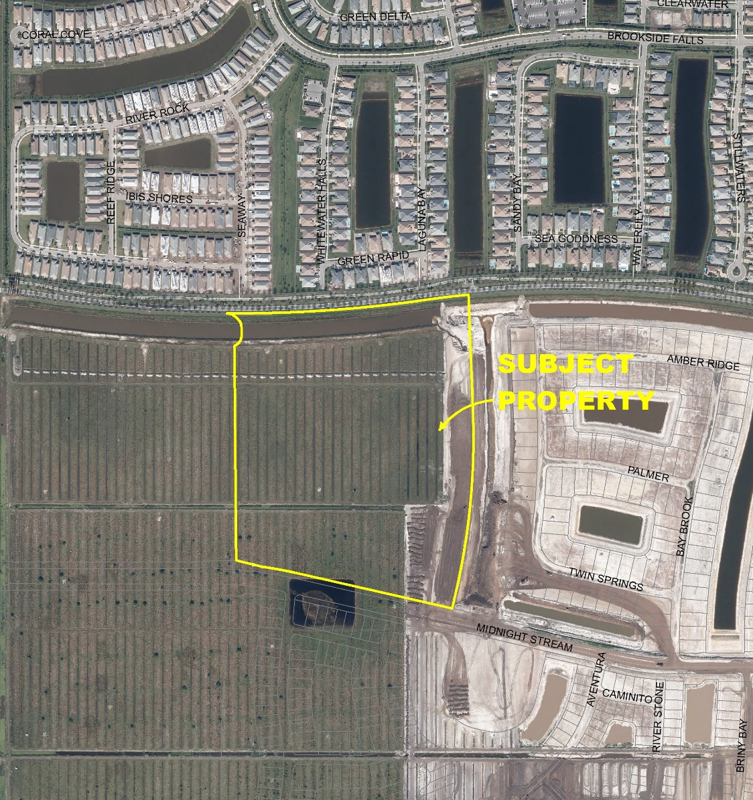
Project Location Map

SUMMARY
Applicant’s Request: | Request for approval of a preliminary and final subdivision plat with construction plans for a project known as Riverland Parcel “D” Plat 7.
Applicant: | Mike Fogarty, Riverland Associates IV, LLLP
Property Owner: | Riverland Associates IV, LLLP
Location: | The property is generally located on the north side of SW Midnight Stream Boulevard, west of SW Riverland Boulevard.
Project Planner: | Francis Forman, Planner II
Project Description
Riverland Associates IV, LLLP, Owners, has requested the proposed preliminary and final plat application to provide 116 single-family lots, open space tracts, private roads, and water management tracts within the Riverland DRI.

Previous Actions and Prior Reviews
The Site Plan Review Committee reviewed the request and recommended approval of the proposed preliminary and final plat at the November 8, 2023, Site Plan Review Committee meeting.

Location and Site Information
Parcel Numbers: | 4319-141-0002-000-9
Property Size: | 41.92 acres
Legal Description: | Being a parcel of land lying within section 20, twonship 37 south, range 39 east, city of Port St. Lucie, St. Lucie County.
Future Land Use: | New Community Development (NCD)
Existing Zoning: | Master Planned Unit Development (MPUD)
Existing Use: | Vacant

Surrounding Uses
Direction | Future Land Use | Zoning | Existing Use
North | NCD | MPUD | Residential
South | NCD | MPUD | Future Residential
East | NCD | MPUD | Future Residential
West | NCD | MPUD | Future Residential
NCD – New Community Development MPUD – Master Planned Unit Development

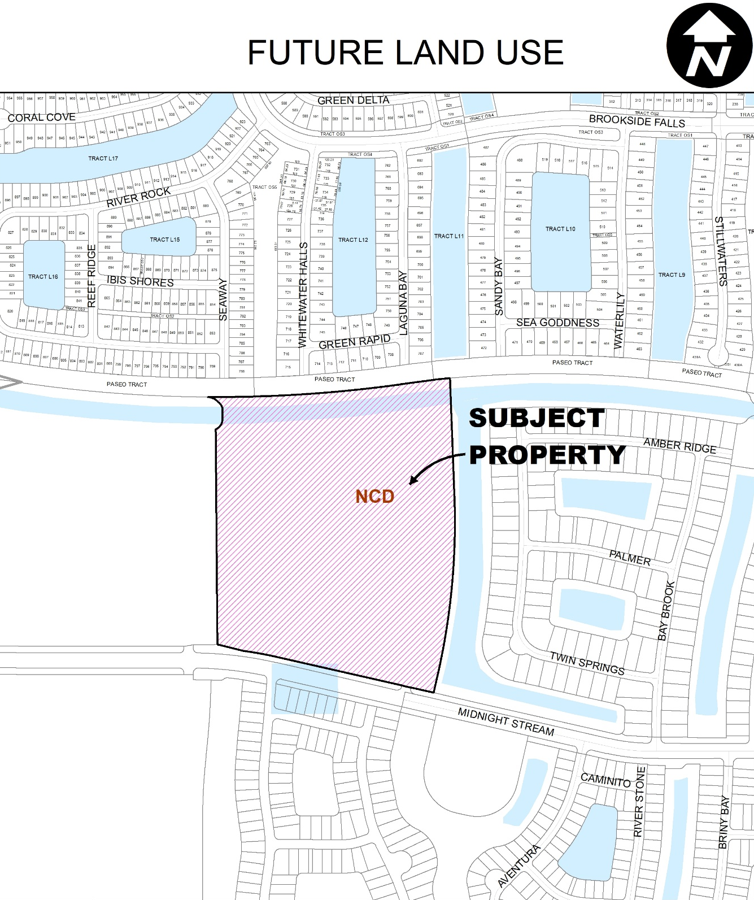

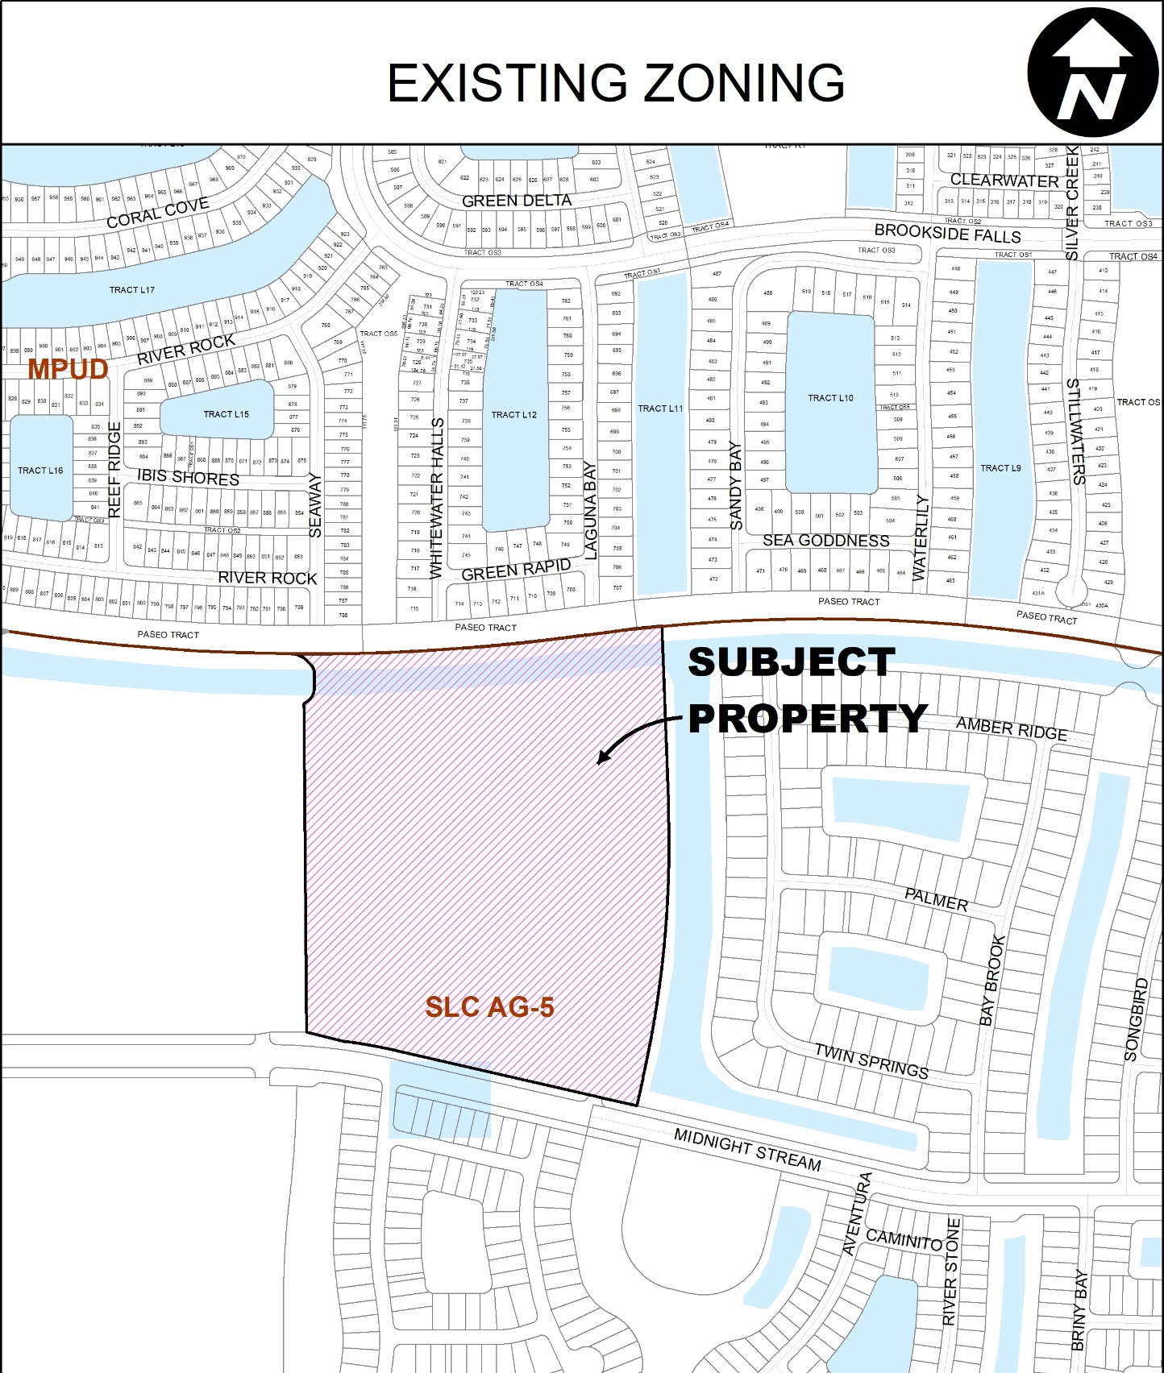

IMPACTS AND FINDINGS
CONCURRENCY REVIEW (CHAPTER 160)
The project has been reviewed for compliance with Chapter 160, City Code and the Riverland/Kennedy DRI egarding the provision of adequate public facilities and documented as follows:

Sanitary Sewer and Potable Water Facilities | The City of Port St. Lucie Utility Systems Department will provide water and sewer service. The construction plans include the necessary water and sewer system extensions to serve the development. A developer’s agreement with the City Utility Systems Department, that is consistent with the adopted level of service, is required prior to issuance of building permits.
Traffic Circulation | See the attached memo from Public Works.
Parks and Recreation Facilities | Per Condition No. 54 of the DRI development order, an agreement for the provision of 141 acres of neighborhood and community park sites has been approved.
Stormwater Management Facilities | The construction plans include paving and drainage plans that are in compliance with the adopted level of service standard.
Solid Waste | Solid waste impacts are measured and planned based on population projections on an annual basis. There is adequate capacity available.
Public School Concurrency Analysis | Per Policy 2.4.2 of the City’s Comprehensive Plan, this development will be exempt from public school concurrency since this plat is for water management and open space tracts.

OTHER
Native Habitat/Tree Protection: Upland preservation/mitigation requirements for the Riverland/Kennedy DRI are addressed in the Development Order. All upland mitigation requirements have been met. The site has been previously cleared.
Fire District: The access location (external and internal) has been reviewed by the Fire District for safety purposes.
Public Art (Chapter 162): To meet the public art requirement, the Developer has proposed a single art piece to be placed within the Riverland Center Development. The art will incorporate the requirements for all of Parcel B, D, and Riverland Center.
STAFF RECOMMENDATION

The Site Plan Review Committee reviewed the request and recommended approval of the preliminary and final plat at the November 8, 2023, Site Plan Review Committee meeting.

Staff recommends approval of the Preliminary and Final Plat with construction plans with the following conditions:
- The plat will not be recorded until a bond in a form reviewed and approved by the City Attorney’s Office is received by Public Works Department and a revised mylar is received and reviewed by staff and the City Attorney’s office.

