
PLANNING AND ZONING STAFF REPORT
January 13, 2025 City Council Meeting

MedSquare-Flagler Healthcare
Preliminary and Final Plat
P24-049
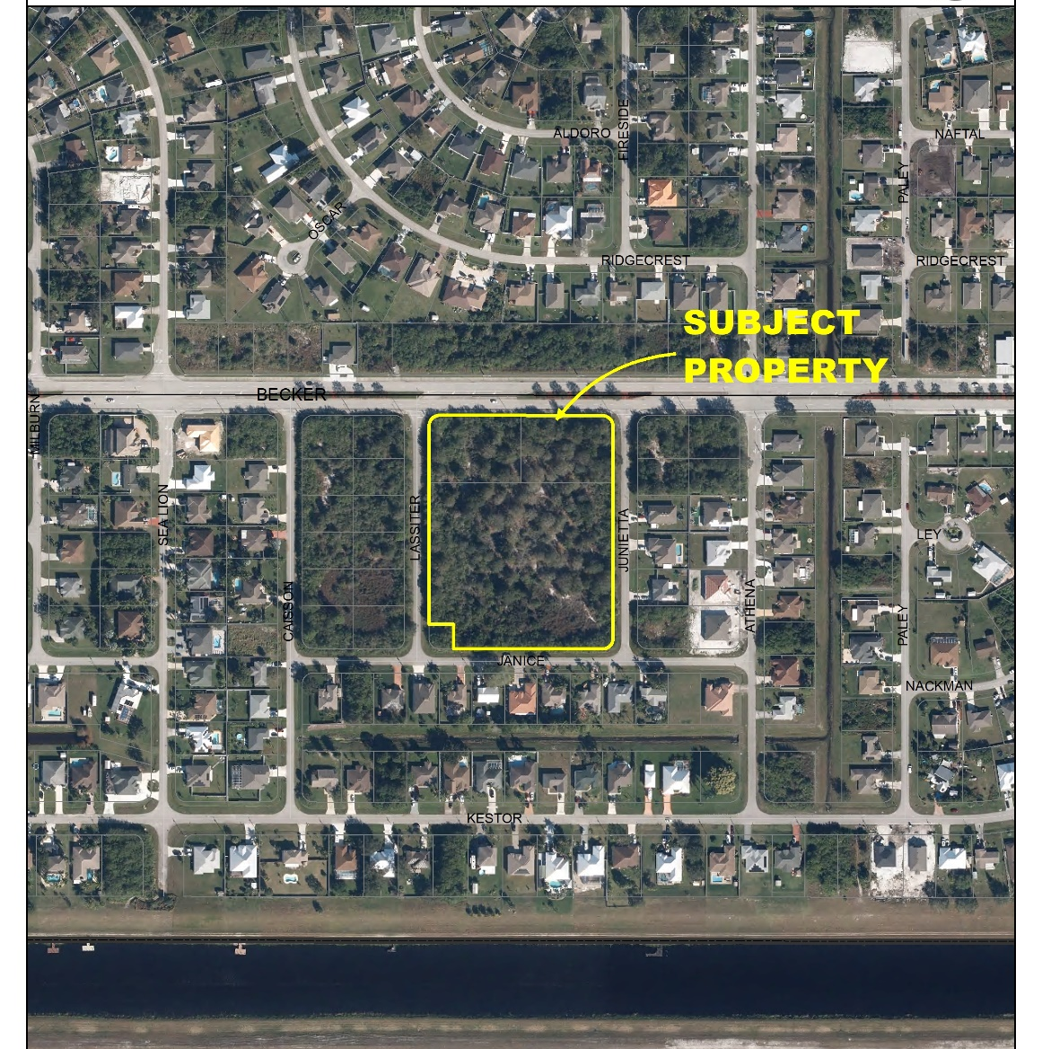
SUMMARY
Applicant’s Request: | A request for approval of a Preliminary and Final Plat for the future use of a medical office building located on the south side of Becker Road. The total area of the site is 5.80 acres.
Applicant: | 2 GHO, Inc. – Pat Lentini
Property Owner: | A M Developments, LLC
Location: | South of Becker Road, between SW Lassiter Terrace and SW Junietta Terrace.
Application Type: (Identify if quasi-judicial) | Preliminary and Final Plat, Consent

Project Description
The applicant is requesting approval of a preliminary and final plat to replat the property as one parcel and to remove ingress/egress easements that traverse the site. The site is 5.8- acre parcel consisting of 3 parcels of land. A major site plan was approved for the subject property by the City Council on May 13, 2024. It allows for a 66,798 square foot medical office building on an undeveloped site, located on the south side of Becker Road.

Previous Actions and Prior Reviews
The Site Plan Review Committee recommended approval for the preliminary and final plat on May 22, 2024.

Location and Site Information
Parcel IDs | 4430-700-0002-000-6, 4430-700-0003-000-3, & 4430-700-0001-000-9
Property Size: | 5.80 acres: 252,648 SF
Legal Description: | Becker Commons (PB 62-1), Lots 1, 2, & 3
Future Land Use: | CL-Limited Commercial
Existing Zoning: | Professional
Existing Use: | Vacant

Surrounding Uses
Direction | Future Land Use | Zoning | Existing Use
North | ROI | P | Vacant
South | RL | RS-2 | Single Family
East | O | RS-2 | Single Family
West | O | RS-2 | Vacant
ROI-Residential, Office, & Institutional, RL- Low Density Residential, O-Office, P-Professional, RS-2-Single-Family Residential-

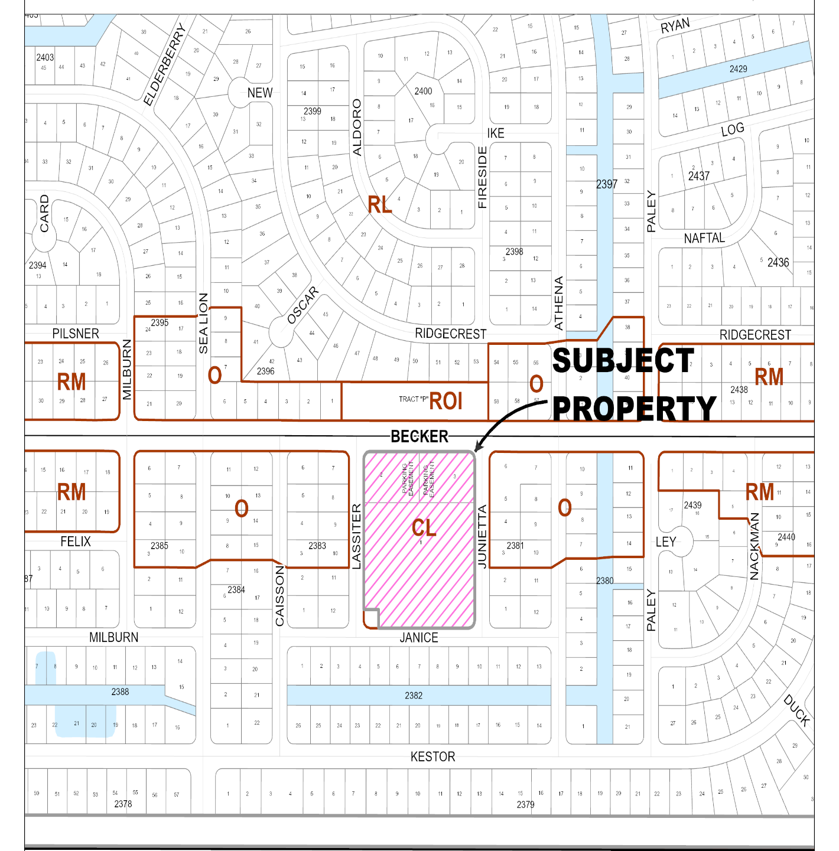

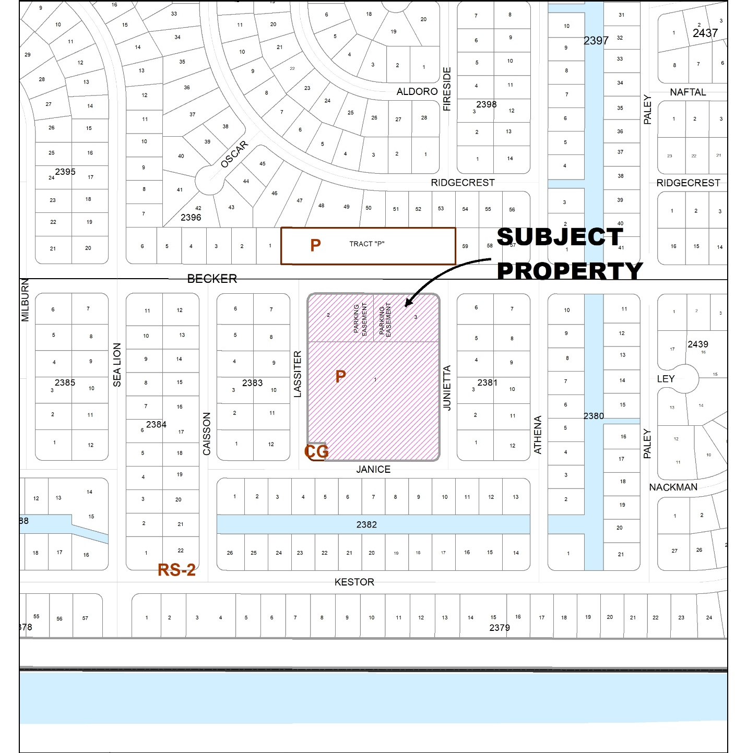

IMPACTS AND FINDINGS
CONCURRENCY REVIEW (CHAPTER 160)
The project was previously reviewed for compliance with Chapter 160, City Code regarding the provision of adequate public facilities. No changes will result from this replat. The review was documented as follows:

Sanitary Sewer and Potable Water Facilities | The subject site is served by the City of Port St. Lucie Utility Systems Department. Utility plans were approved as part of the construction plans for the associated site plan (P23-199).
Traffic Circulation | Addressed as part of the review and approval of the associated site plan (P23-199).
Parks and Recreation Facilities | Not applicable
Stormwater Management Facilities | Addressed as part of the review and approval of the associated site plan (P23-199).
Solid Waste | Addressed as part of the review and approval of the associated site plan (P23-199).
Public School Concurrency Analysis | Not applicable

NATURAL RESOURCE PROTECTION
The project has been reviewed for compliance with the requirements of Chapter 157, Natural Resource Protection Code and documented as follows:
Native Habitat/Tree Protection: An environmental assessment report was prepared for the subject property. The site is undeveloped, comprised of Mesic flatwoods and dry flatwoods native upland habitat. Gopher tortoise burrows were found on site. A new gopher tortoise survey will be required before the property is cleared. No other state or federally listed plant/animal species or their habitat(s) were observed on site. There are no wetlands on the property. The site is subject to upland habitat mitigation and the applicant has elected to make a payment into the Conservation Trust Fund in lieu of on-site preservation.
Wildlife Protection: The site shall be evaluated for any resident wildlife prior to building. If any listed species are present on the site, the applicant will be required to obtain a permit from the Florida Department of Environmental Protection prior to development.

OTHER
Fire District: The access location (external and internal) were reviewed by the Fire District as part of the review of the associated site plan (P23-199).
Public Art (Chapter 162): The site plan is subject to Chapter 162 of the Code of Ordinances, Art in Public Places. All public construction projects meeting the applicability requirements of Chapter 162 must elect one of three methods for providing public art within ninety (90) days of the issuance of the first building permit. The three options are artwork on site, fee in lieu of providing public art onsite, or a combination of artwork on site and payment in lieu. At this time, the applicant has identified the fee in lieu as the preferred option.

Related Projects

P23-199 MedSquare - The City Council on May 14, 2024, approved a Major Site Plan for the property.

STAFF RECOMMENDATION

The Planning and Zoning Department staff finds the request to be consistent with the direction and intent of the City’s Land Development Regulations and policies of the Comprehensive Plan.
The Site Plan Review Committee recommended approval of the MedSquare-Flagler Healthcare preliminary and final subdivision plat at their meeting on May 22, 2024.

