
PLANNING AND ZONING STAFF REPORT
September 5, 2024, Planning and Zoning Meeting

Ekonomy Self Storage
Rezoning
P24-050
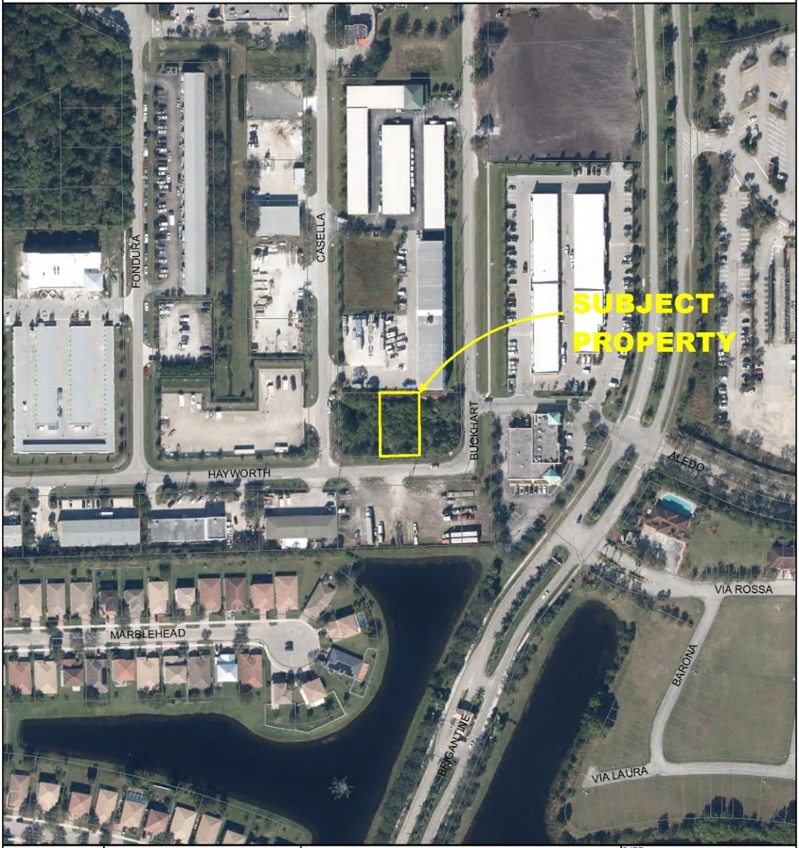
Project Location Map

SUMMARY
Applicant’s Request: | Rezoning from Single-Family Residential (RS-2) to Service Commercial (CS)
Applicant: | Lisa Reves
Property Owner: | Ekonomy Self Storage
Location: | The property is generally located south of SW Gatlin Boulevard and west of SW Buckhart Street.
Address: | 1915 SW Hayworth Avenue
Project Planner: | Cody Sisk, Planner II

Project Description
The applicant is requesting the rezoning of an approximately 0.24-acre parcel, from Single-Family Residential (RS-2) to Service Commercial (CS). The property is legally described as Port St. Lucie Section 31, Block 1705, Lot 14 (OR Book 3943, Page 2230). The parcel’s address is 1915 SW Hayworth Avenue, which is located north of SW Hayworth Street, between SW Casella and SW Buckhart Street.

The 0.24-acre parcel of land currently remains undeveloped and vacant. Adjacent to this parcel is the Ekonomy Self Storage facility, which includes a self-storage center and U-Haul rental services. The Applicant proposes to develop the vacant lot to serve as temporary storage for rental vehicles.

The applicant has concurrent land use amendment (P24-094) and site plan (P24-051) applications that are under review. This rezoning application will be heard concurrently with the small-scale Future Land Use Map amendment.

Background
The City Council approved a variance by resolution on July 24, 2023 (P23-176).

The variance was to the City of Port St. Lucie Land Use Conversion Manual requirements for Conversion Area 23, for lot size and frontage requirements to allow the rezoning of one lot. A condition of approval was also applied to the variance application which would ensure Cross access to lots 13 and 15 from lot 14 shall be required. Prior to site plan approval the property owner will be required to complete a unity of title application to unify the existing site to the north to the subject site.

Public Notice Requirements
Public notice was mailed to owners within 750 feet of the property and the item was included in the ad for the April 2, 2024, Planning & Zoning Board meeting.

Location and Site Information
Parcel Number: | 3420-650-1001-000-0
Property Size: | 0.24 acres
Legal Description: | Port St Lucie Section 31, Block 1705, Lot 14
Future Land Use: | General Commercial (CG), proposed Service Commercial (CS)
Existing Zoning: | Single-Family Residential (RS-2)
Existing Use: | Vacant
Requested Zoning: | Service Commercial (CS)
Proposed Use: | Rental vehicle storage

Surrounding Uses

Direction | Future Land Use | Zoning | Existing Use
North | CS | CS | Self-Storage Facility
South | CS | CS | Vacant
East | CG | RS-2 | Vacant
West | CG | RS-2 | Vacant
CS-Service Commercial, CG- General Commercial, RS-2-Single Family Residential

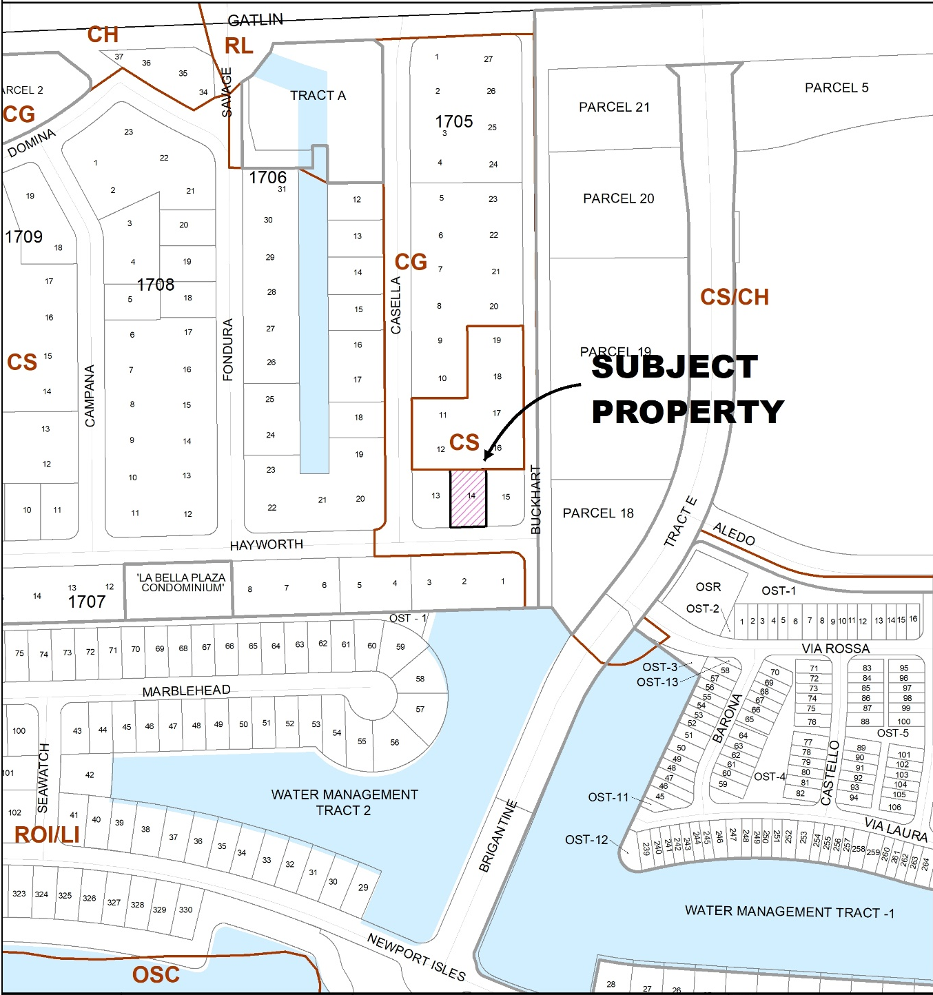
Future Land Use Map
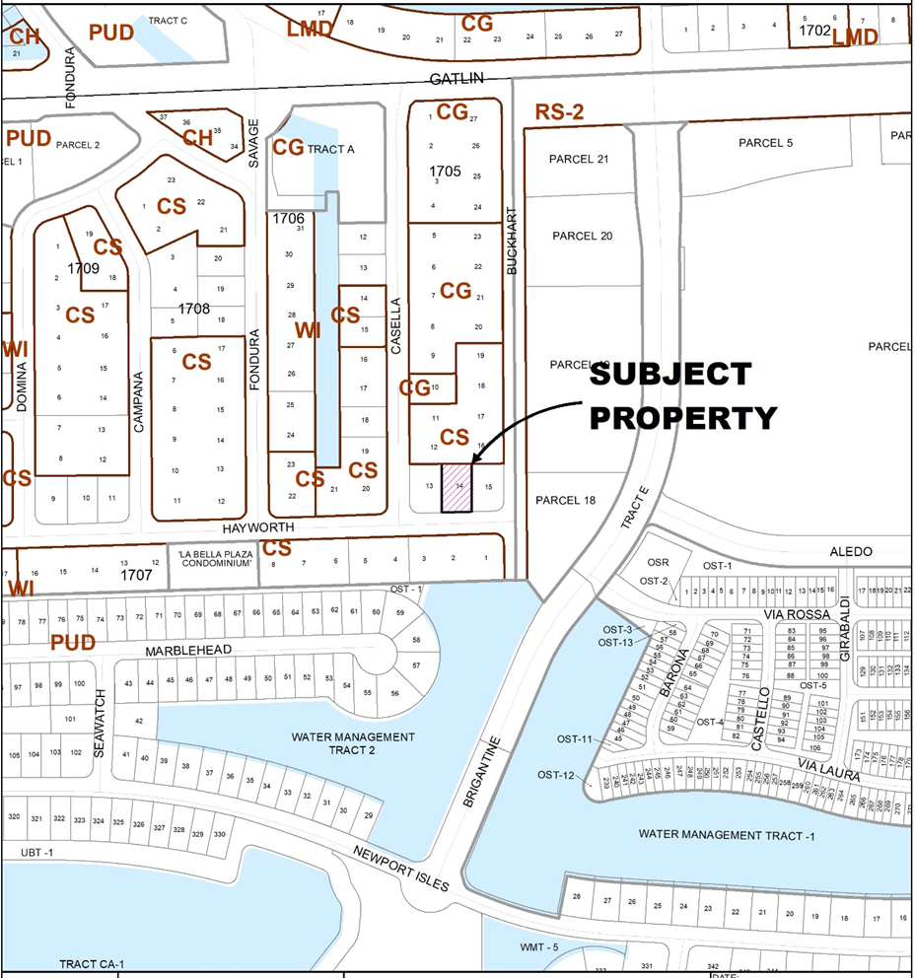
Zoning Map

IMPACTS AND FINDINGS
COMPREHENSIVE PLAN REVIEW
Land Use Consistency: Proposed zoning of General Commercial is compatible with Policy 1.1.4.13 and future land use classification of Service Commercial (CS).
ZONING REVIEW
Justification Statement: The Applicant does not intend to build any structures on Lot 14 at this time. Ekonomy Self Storage is located to the north of Lot 14 and is a self-storage facility which rents U-Haul vehicles. The Applicant intends to use Lot 14 as temporary storage for rental vehicles.
Staff Analysis: The rezoning classification complies with the direction and intent of the City of Port St. Lucie Comprehensive Plan. The Service Commercial Zoning District (CS) is compatible with the Service Commercial (CS) future land use classification per Policy 1.1.4.13 of the Future Land Use Element.
ENVIRONMENTAL REVIEW
A gopher tortoise survey is required prior to development.
RELATED PROJECTS
Ekonomy Self Storage variance; granted by the City Council on July 24, 2023 (P23-176).

Ekonomy Self Storage Comprehensive Plan Amendment (P24-094)

STAFF RECOMMENDATION

The Planning and Zoning Department staff finds the request to be consistent with the direction and intent of the future land use map and policies of the City's Comprehensive Plan and recommends approval.
Planning and Zoning Board Action Options:
- Motion to recommend approval to the City Council
- Motion to recommend denial to the City Council

Please note: Should the Board need further clarification or information from either the applicant and/or staff, it may exercise the right to table or continue the hearing or review to a future meeting.

