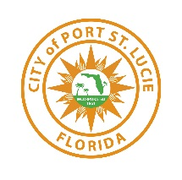
PLANNING & ZONING DEPARTMENT STAFF REPORT
January 13, 2025 City Council Meeting

Verano South PUD 1- POD D- Plat No. 6
Final Plat with Construction Plans
P24-048

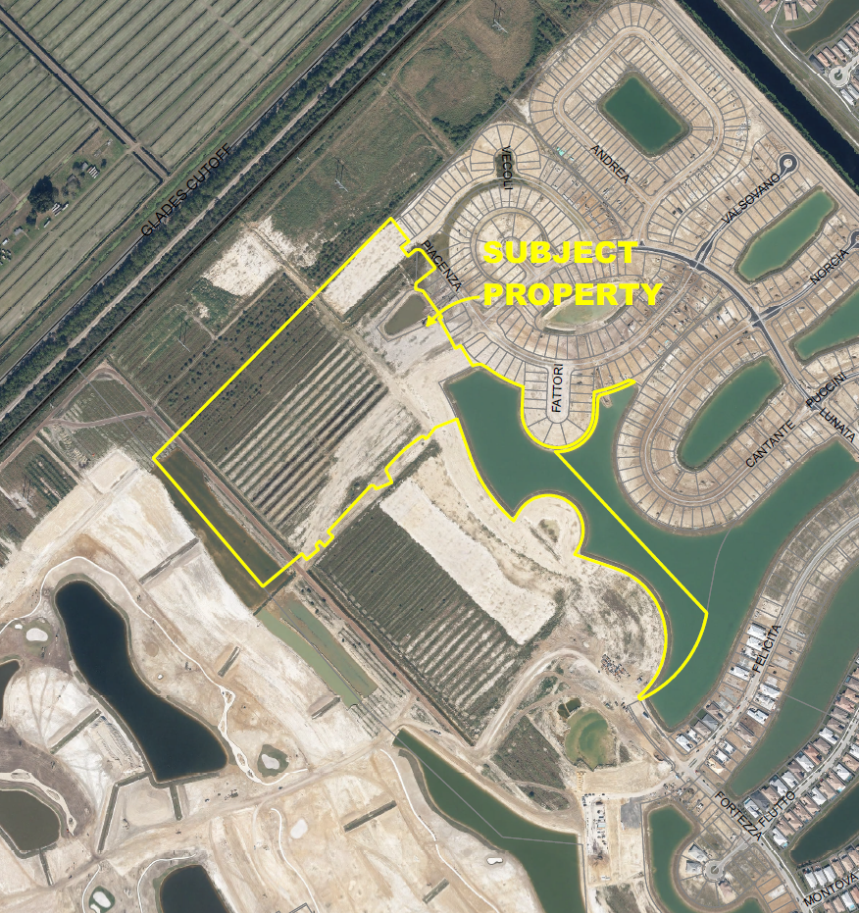

Aerial Map

SUMMARY
Applicant’s Request: | Request for approval of a Final Plat with Construction Plans that is approximately 52.6 acres in area and includes 123 lots for a project known as Verano South PUD 1 POD D Plat No. 6.
Applicant: | Daniel Sorrow of Cotleur-Hearing
Property Owner: | Verano Development LLC
Location: | This property is located within the Verano DRI, south of the C-24 Canal, west of I-95, and north of Crosstown Parkway.
Project Planner: | Daniel Robinson, Planner III

Project Description

The application is for a Final Plat with Construction Plans. The proposed development is to create a total of 123 single-family lots.
Previous Actions and Prior Reviews
The Site Plan Review Committee unanimously recommended approval of this Final subdivision plat with construction plans on May 8, 2024.
Related Projects
P22-211 – Verano South Pod D PUD Amendment Number 4 – The Planned Unit Development (PUD) document was approved by the City Council on February 12, 2024.

P22-294 - Verano South- POD D- Plat No. 6 Preliminary Subdivision Plat with Construction Plans was approved per Resolution No. 23-R111 by City Council on October 9, 2023.

Location and Site Information
Property Size: | Approximately 52.6 acres
Legal Description: | Being a Replat of all of Tracts CA-8, CA-9, CA-12, Water Managements Tract 2, and Water Management Tract 5, of Verno South PUD 1 Plat No. 5, According to the Plat Thereof as Recorded in Plat Book 129, Pages 1 Though 10, Inclusive of The Public Records of St. Lucie County, Florida and Being a portion of Sections 29 and 32, Township 36 South, Range 39 East, City of Port St. Lucie, St. Lucie County, Florida.
Future Land Use: | Residential Golf Course (RGC)
Existing Zoning: | PUD (Planned Unit Development)
Existing Use: | Vacant

Surrounding Uses

Direction | Future Land Use | Zoning | Existing Use
North | RGC | PUD | Verano Development
South | RGC | PUD | Verano Development
East | RGC | PUD | Verano Development
West | RGC | PUD | Verano Development
RGC (Residential Golf Club) – PUD (Planned Unit Development)

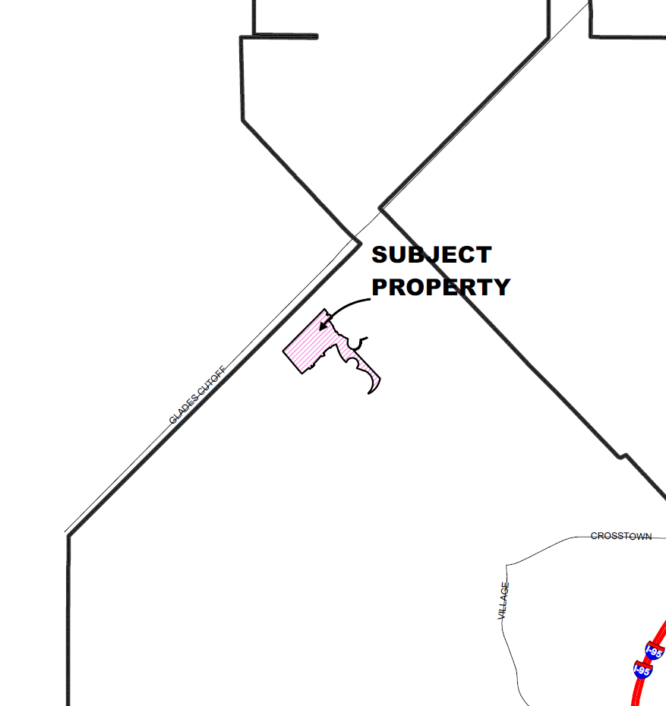

Location Map

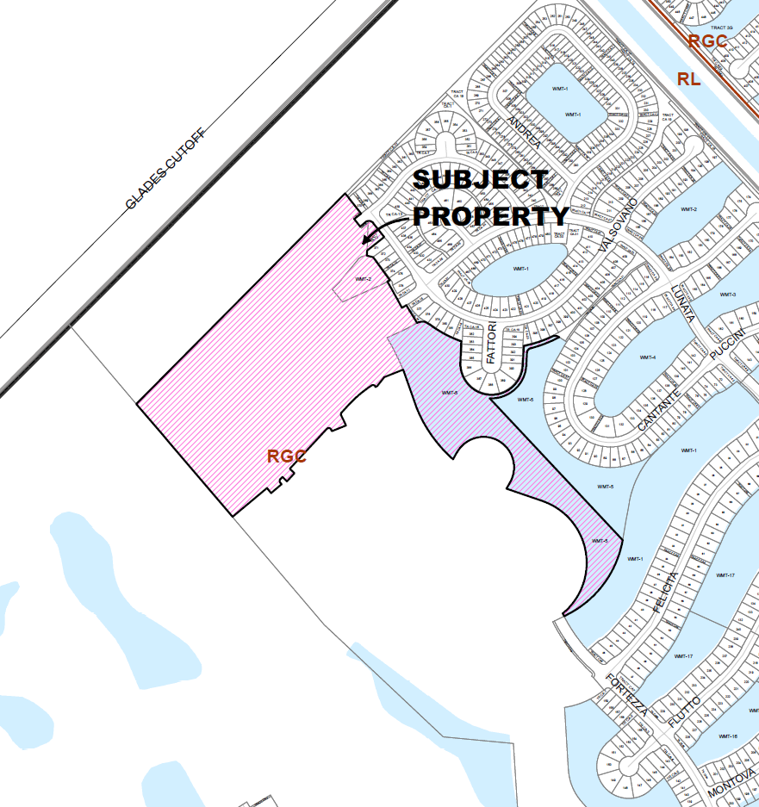

Future Land Use

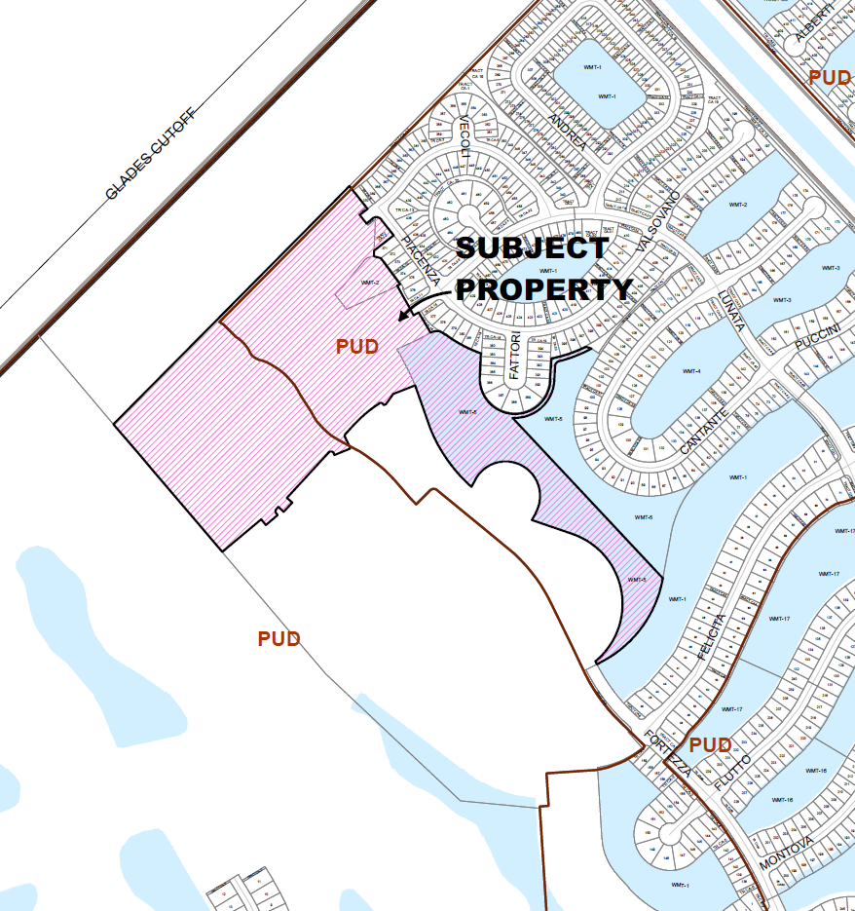

Zoning Map

IMPACTS AND FINDINGS
CONCURRENCY REVIEW (CHAPTER 160)
The project has been reviewed for compliance with Chapter 160, City Code, and the Verano Development of Regional Impact (DRI) Development Order, regarding provision of adequate public facilities and documented as follows:

Sanitary Sewer and Potable Water Facilities | Sewer/water will be provided by Port St. Lucie Utility Systems Department. A developer's agreement with the City Utility Systems Department, that is consistent with the adopted level of service, is required prior to issuance of building permits.
Traffic Circulation | This application and Traffic Report prepared by MacKenzie Engineering & Planning, Inc. dated January 23, 2024 has been reviewed by the Public Works Department and the transportation elements of the project were found to be in compliance with the adopted level of service and requirements of the Verano Development Order, Chapter 156 of City Code, and Public Works Policy 19-01pwd. Verano South POD D Plat 6 is within the previously approved POD D, which proposes 1,040 dwelling units and does not warrant any changes to the previously approved transportation conditions of the Verano Development Order.
Parks and Recreation Facilities | As indicated by the Verano DRI Development Order condition 57, the applicant is required to provide a 50-acre park site for recreational uses. The site is to be platted and dedicated to the City.
Stormwater Management Facilities | Project will include paving and drainage plans that are in compliance with the adopted level of service
Solid Waste | Adequate capacity is available for future development.
Public School Concurrency Analysis | As required by the Verano DRI Development Order condition 56, the applicant provided the St. Lucie School District with a 48-acre high school site. An additional 25 acres will be required if by the time of development of the 6,000th residential unit, the development generates 2,501 students or more.
Native Habitat/Tree Protection: Upland preservation/mitigation requirements for the Verano DRI are addressed in the Development Order. There are no preservation/mitigation requirements for this property.
OTHER
Fire District: The access location (external and internal) has been reviewed by the Fire District for safety purposes.
Public Art (Chapter 162): Public Art for this location was previously addressed.
Traffic Impact Analysis (by Public Works):
No additional roadway requirements are triggered by this replat.
STAFF RECOMMENDATION

The Site Plan Review Committee recommended approval of Verano South PUD 1-POD D-Plat No. 6 Final Plat and Construction Plans on May 8, 2024.

