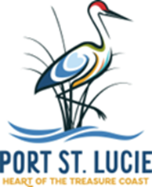
PLANNING AND ZONING STAFF REPORT
January 13, 2025 City Council Meeting

Tradition 4 Brynlie
Preliminary and Final Subdivision Plat with Construction Plans
P22-277
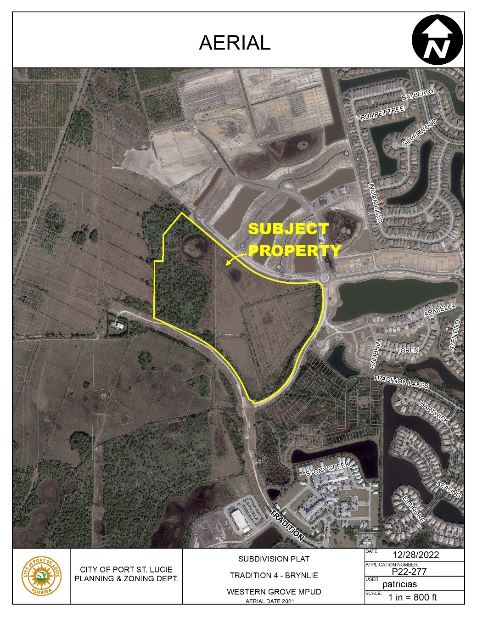
Project Location Map
SUMMARY
Applicant’s Request: | Request for approval of a preliminary and final subdivision plat with construction plans for a project known as Tradition 4 Brynlie that will include 210 single-family residential lots and SW Fernlake Drive, from SW Westcliffe Lane south to its existing terminus.
Agent/Applicant: | Christopher Hollen, P.E., Kimley-Horn & Associates, Inc.
Property Owner(s): | Mattamy Palm Beach, LLC and the City of Port St. Lucie
Location: | Generally located north of SW Tradition Parkway and south of SW Westcliffe Lane.
Project Planner: | Bethany Grubbs, AICP, Senior Planner

Project Description
Mattamy Palm Beach, LLC, has applied for preliminary and final subdivision plat approval, including construction plans, for a new residential community within the Tradition area. This area is part of the broader Tradition Master Planned Unit Development (MPUD), which spans approximately 3,038 acres. The proposed project, known as Brynlie, covers roughly 80.539 acres and will consist of 210 single-family residential lots, along with an amenity tract, open space tracts, water management tracts, a private roadway tract, and a public roadway tract (which will be an extension of SW Fernlake Drive). The development will provide two access points. A full, primary access point off SW Fernlake Drive and a secondary, right-in-right-out access point from SW Westcliffe Lane.
Brynlie is situated within the Tradition Development of Regional Impact (DRI), generally bounded by SW Tradition Parkway to the south, SW Westcliffe Lane to the north, and SW Fernlake Drive to the east.
The development will provide for the construction of the Fernlake Drive extension from its current terminus west of the Emery subdivision north to connect with SW Westcliffe Lane. A bond has been approved and secured for the subdivision infrastructure improvements. The subdividing of this segment of Fernlake Drive satisfies the Tradition DRI development order Condition 5.N.6.g.
Previous Actions and Prior Reviews
The Site Plan Review Committee reviewed this application at the June 12, 2024, meeting and recommended approval.

Location and Site Information
Parcel ID(s): | 4305-701-0001-000-7, 4308-132-0001-000-0
Property Size: | Approximately 80.54 acres
Legal Description: | See attached plat.
Future Land Use: | NCD (New Community Development)
Existing Zoning: | MPUD (Master Planned Unit Development)
Existing Use: | Vacant Land

Surrounding Uses
Direction | Future Land Use | Zoning | Existing Use
North | NCD | MPUD | Esplanade at Tradition Subdivision
South | NCD | MPUD | Undeveloped (Traditional Regional Park)
East | NCD | MPUD | Emery and the Estates at Tradition Subdivisions
West | NCD | MPUD | Vacant Land
NCD-New Community Development, MPUD-Master Planned Unit Development

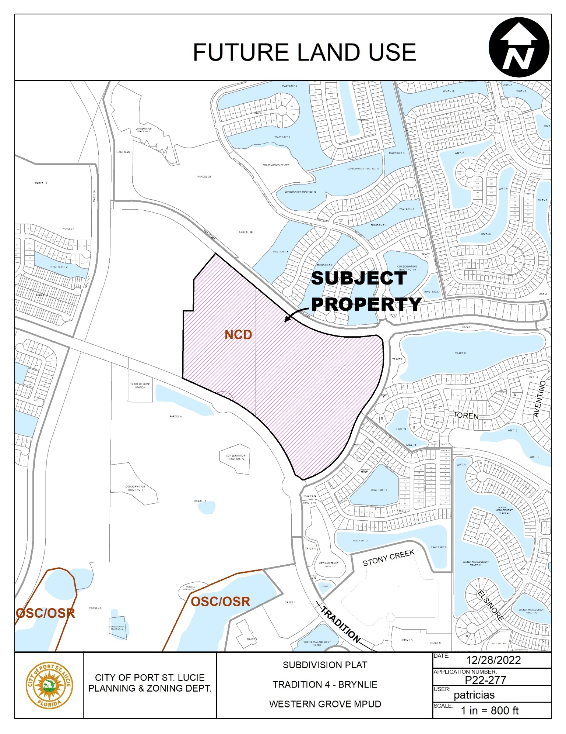
Future Land Use

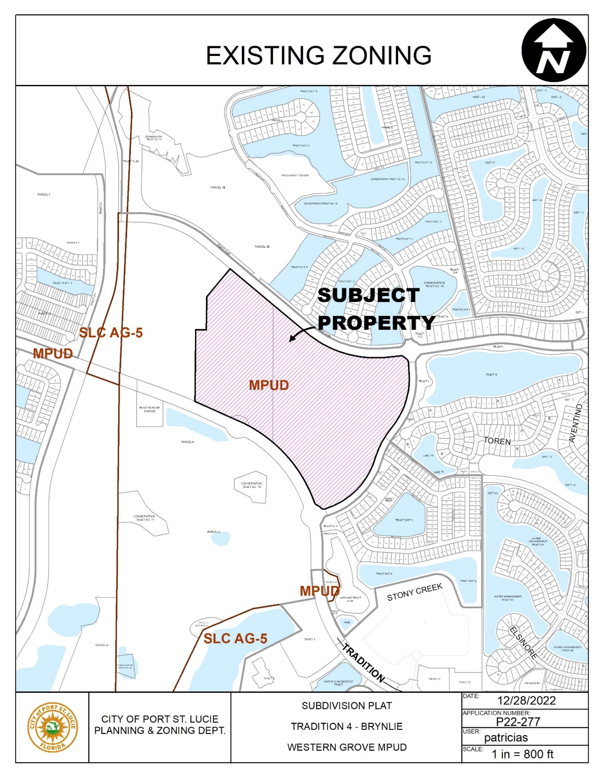
Zoning

IMPACTS AND FINDINGS
CONCURRENCY REVIEW (CHAPTER 160)
The project has been reviewed for compliance with the Tradition Development of Regional Impact (DRI) Development Order to ensure that adequate public facilities and services are available with the development impacts. Staff has reviewed the application for concurrency as follows:
Sanitary Sewer and Potable Water Facilities | The City of Port St. Lucie Utility Systems Department will provide water and sewer service. A developer’s agreement with the City Utilities Department, that is consistent with the adopted level of service, is required prior to issuance of building permits.
Traffic Circulation | This application and Traffic Report prepared by MacKenzie Engineering & Planning, Inc. dated January 2023, has been reviewed by the Public Works Department and the transportation elements of the project were found to be in compliance with the adopted level of service and requirements of Chapter 156 of City Code, the Tradition DRI Development Order and Public Works Policy 19-01pwd.  This phase of the proposed development includes 210 single family homes which is expected to generate 208 PM peak hour driveway trips per the Institute of Traffic Engineer’s Trip Generation Manual, 11th Edition.
Parks and Recreation Facilities | Requirements for public parks and recreational facilities are addressed under Condition 67 of the DRI Development Order. In 2008, the City acquired approximately 110.383 acres of land from the Tradition Development Company, LLC, for Tradition Regional Park in accordance with the recreation and open space requirements of the Tradition DRI and the Western Grove DRI. A site plan has been submitted a site plan for Tradition Regional Park, Phase 1 (P21-116).
Stormwater Management Facilities | The project includes paving and drainage plans that meet the required level of service.
Solid Waste | Solid waste impacts are measured and planned based on population projections on an annual basis. There is adequate capacity available.
Public School Concurrency Analysis | As required by the DO, prior to January 1, 2005, the developer provided the City of Port St. Lucie and the St.  Lucie County School Board a plan for the provision of necessary school facilities concurrent with the development of the residential portion of the Tradition DRI. The Agreement is dated June 26, 2006, and recorded in OR Book 2597, Page 2157, of the Official Records of St. Lucie County, Florida via Resolution 08-R82.

NATURAL RESOURCE PROTECTION
The project has been reviewed for compliance with the requirements of the Tradition DRI Development Order for protection of habitat, vegetation, and wildlife.
Native Habitat Protection: The developer shall maintain nine (9) upland conservation areas shown in the Tradition Development Plan Map H totaling approximately 75.84 acres.
Wildlife Protection: A 100% gopher tortoise habitat survey must be conducted prior to any land clearing or site work.

OTHER
Fire District: The access location (external and internal) has been reviewed by the Fire District for safety purposes.
Art in Public Places: This project is subject to Chapter 162 of the Code of Ordinances, Art in Public Places. Mattamy Palm Beach, LLC included the subject development on the list of identified projects whose public art requirements will be met via the approved alternative equivalent proposal for public art known as Heart in the Park.
STAFF RECOMMENDATION
The Planning and Zoning Department staff finds the request to be consistent with the direction and intent of the approved zoning, policies of the City's Comprehensive Plan, and City Subdivision Code. The Site Plan Review Committee recommended approval of the preliminary and final subdivision plat with construction plans on June 12, 2024.

