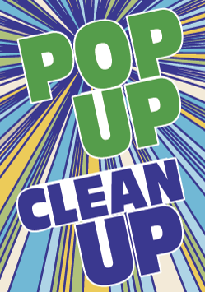 Pop-Up Cleanup Post-Event Details

Location, Date, Start & Finish Time:
Turtle Run Park, 1945 SW Cameo Blvd
August 23, 2025; 8-10am
_________________________________________________________________________

Attendance: 43 Volunteers
Includes Treasure Coast High School Students and Chaperone; John Carroll HS student, Adopt-A-Street groups including the Neumanns, Pick Me Up trash, and Ninja Family 27, plus many other volunteers from previous KPSLB cleanups.

Litter Collection: 107 pounds
Includes one propane tank = 19 pounds

Event Total = 107 pounds

