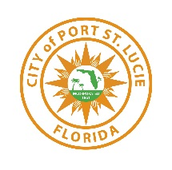
PLANNING DEPARTMENT STAFF REPORT
January 13, 2024 City Council Meeting

Crosstown Parkway Plat 2-B
Final Subdivision Plat with Construction Plans
P24-060
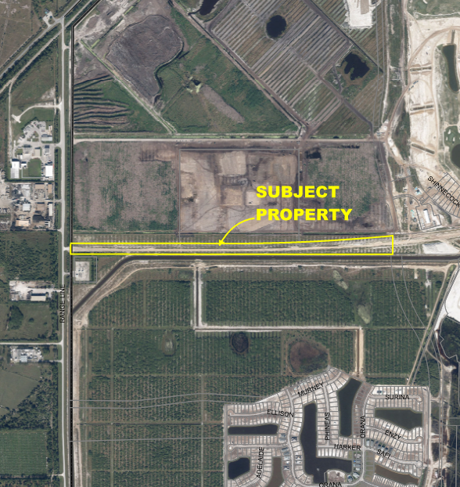

Project Location Map

SUMMARY
Applicant’s Request: | Request for approval of a Final subdivision plat with construction plans for a project know as Crosstown Parkway Pat 2-B.
Applicant: | Daniel Sorrow, Cotleur & Hearing
Property Owner: | City of Port St. Lucie
Location: | South of Verano Development and North of Tradition Development, western continuance of Crosstown parkway west of Village Parkway.
Project Planner: | Daniel Robinson, Planner III

Project Description
The proposed subdivision plat will create the public road right- of- way tract for Crosstown Parkway west to Range Line Road, approximately 4,636 feet.

Related Projects
P22-169 Crosstown Parkway Plat 2-B Preliminary Plat was approved per Resolution No. 23-R51, by City Council on April 22, 2023.

Location and Site Information
Property Size: | Approximately 18.16 acres
Legal Description: | Being a Portion of West Virginia Extension, As Described in Official Records Book 2186, Page 548, Public Records of St. Lucie County, Florida and Lying within Section 6, Township 37 South, Range 39 East, St. Lucie County, Florida, in The City of Port St. Lucie, Florida
Future Land Use: | Residential Golf Course (RGC)
Existing Zoning: | St. Lucie County AG-5
Existing Use: | Vacant land

Surrounding Uses

Direction | Future Land Use | Zoning | Existing Use
North | RGC | AG-5 | Vacant
South | NCD | MPUD | Tradition Development
East | N/A | N/A | vacant
West | RGC | SLC Ag-5 | Vacant

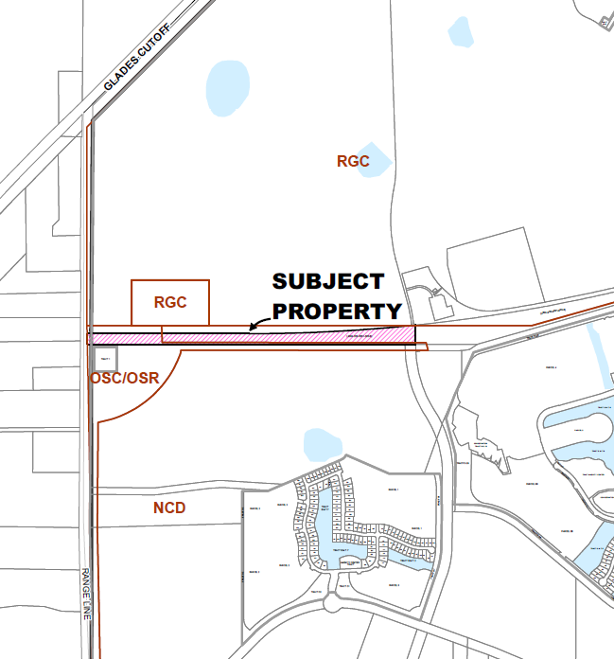

Future Land Use

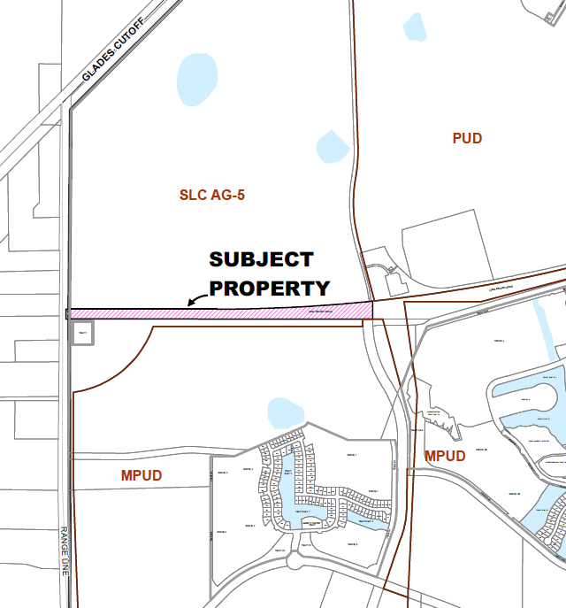

Zoning Map

IMPACTS AND FINDINGS

CONCURRENCY REVIEW (CHAPTER 160)
The project has been reviewed for compliance with Chapter 160, City Code, regarding provision of adequate public facilities and documented as follows:

Sanitary Sewer and Potable Water Facilities | N/A
Traffic Circulation | This application has been reviewed by the Public Works Department and the transportation elements of the project were found to be in compliance with the adopted level of service and requirements of the Verano Development Order, Chapter 156 of City Code, and Public Works Policy 19-01pwd. This application does not warrant any changes to the previously approved transportation conditions of the Verano Development Order.
Parks and Recreation Facilities | N/A
Stormwater Management Facilities | The construction plans include paving and drainage plans that are in compliance with the adopted level of service standard.
Solid Waste | N/A
Public School Concurrency Analysis | N/A

STAFF RECOMMENDATION

The Site Plan Review Committee recommended approval of the final plat and construction plans at their meeting of July 10, 2024.

