
PLANNING AND ZONING STAFF REPORT
December 3, 2024, Planning and Zoning Meeting

Globe Townhomes
LMD Conceptual Plan Amendment
P24-117
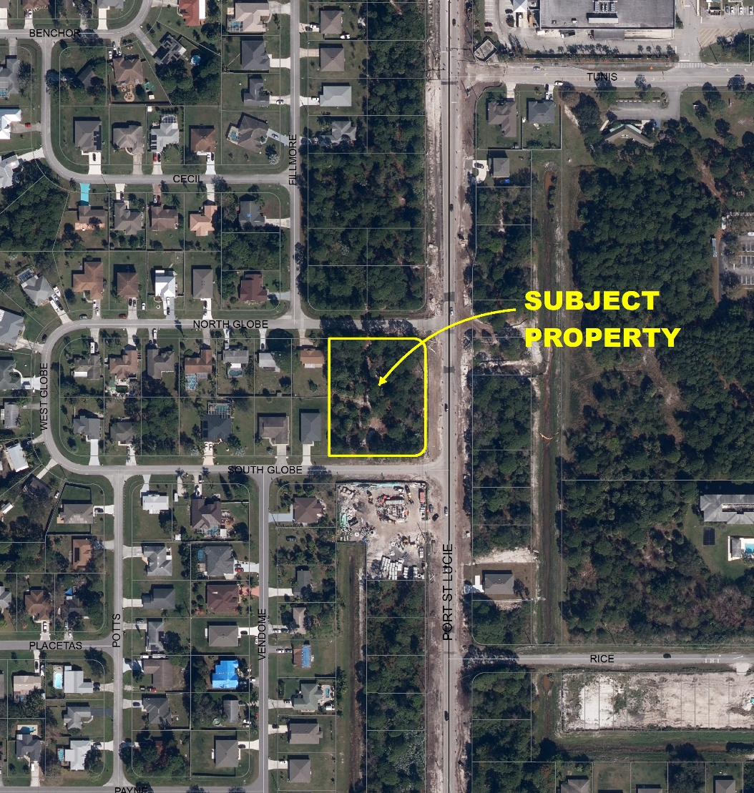
Project Location Map

SUMMARY
Applicant’s Request: | This is a request to amend an LMD Conceptual plan to allow for the construction of a 13-unit multifamily project.
Applicant: | Abraham Chabab, Abraham Chabab, Inc.
Property Owner: | Globe Ave, LLC
Location: | The property is located between SW North Globe Avenue and SW South Globe Avenue, on the west side of SW Port St. Lucie Boulevard.
Address: | 913 SW South Globe
Project Planner: | Francis Forman, Planner II
Project Description
The Applicant, Globe Ave, LLC, is requesting a change to the conceptual plan for a 1.2-acre site. Section 158.155(P) of the Zoning Code requires the plans to be brought back through the public hearing process with any proposed changes. The existing conceptual plan is for a 3,748 square foot restaurant with 1,172 square feet of the restaurant being outdoor seating area. The proposed conceptual plan is to amend the use for the purpose of constructing a 2-story, 8-unit multifamily building fronting on SW Port St. Lucie Boulevard and a 1-story, 5-unit multifamily building located on the western portion of the site for a total of 13 units.

The property has a future land use classification of Residential, Office and Institutional (ROI), and a zoning designation of Limited Mixed Use (LMD). The proposed request to amend the approved conceptual plan does not require the property to be rezoned from the LMD zoning district, therefore the current zoning is compatible with the existing land use.

Previous Actions and Prior Reviews

P03-374 – Globe Center (St. Lucie Realty) – The zoning for this property was changed from Single-Family Residential (RS-2) to LMD in 2003. The rezoning approved a conceptual plan for the property to construct a 10,200 square foot office/retail building.

P22-226 – Globe Avenue Restaurant – LMD conceptual plan amendment to reconfigure the site for the use of a 3,748 square foot restaurant with outdoor seating.

P23-042 – Globe Avenue Restaurant – Site plan approval for a 3,748 square foot restaurant with 1,172 square feet of outdoor seating.

The Site Plan Review Committee recommended approval of the LMD conceptual plan at a meeting of the Site Plan Review Committee on October 23, 2024.

Public Notice Requirements
Notice of this request to change the conceptual plan was mailed on November 21, 2024, to owners of property within a 750-foot radius of the subject property.

Location and Site Information
Parcel Number: | 3420-570-0276-000-6
Property Size: | 1.2 acres, more or less
Legal Description: | Port St. Lucie Section 15, Block 1449, Lots 8-12 (Plat Bk 13, Pg 6)
Future Land Use: | ROI- Residential, Office and Institutional
Existing Zoning: | Limited Mixed Use (LMD)
Existing Use: | Vacant

Surrounding Uses

Direction | Future Land Use | Zoning | Existing Use
North | ROI | RS-2 | Vacant
South | ROI | LMD | Vacant
East | ROI | RS-2 | Vacant
West | RL | RS-2 | Residential
ROI – Residential, Office and Institutional RL – Low Residential
RS-2 – Single-Family Residential

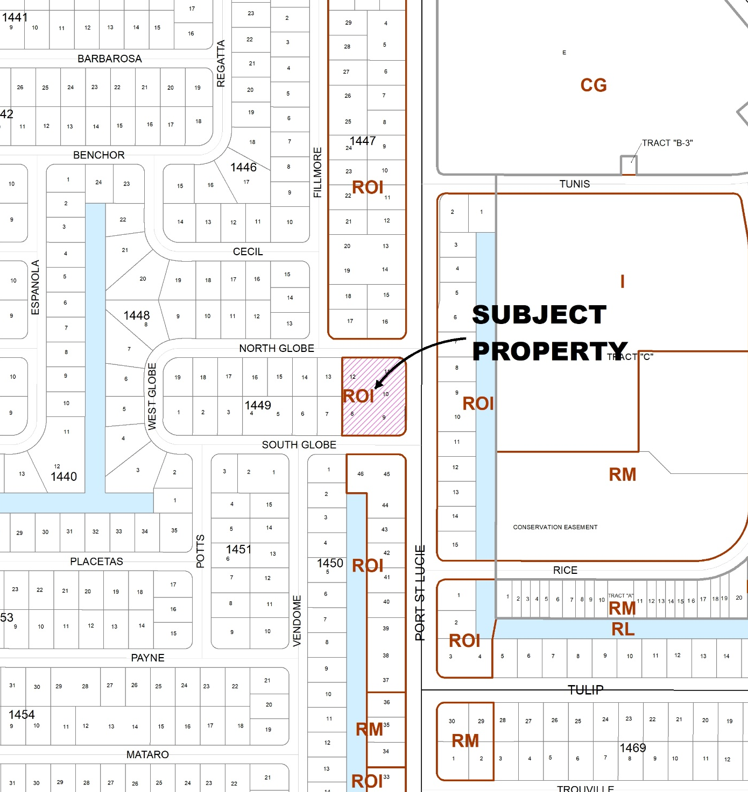
Future Land Use Map

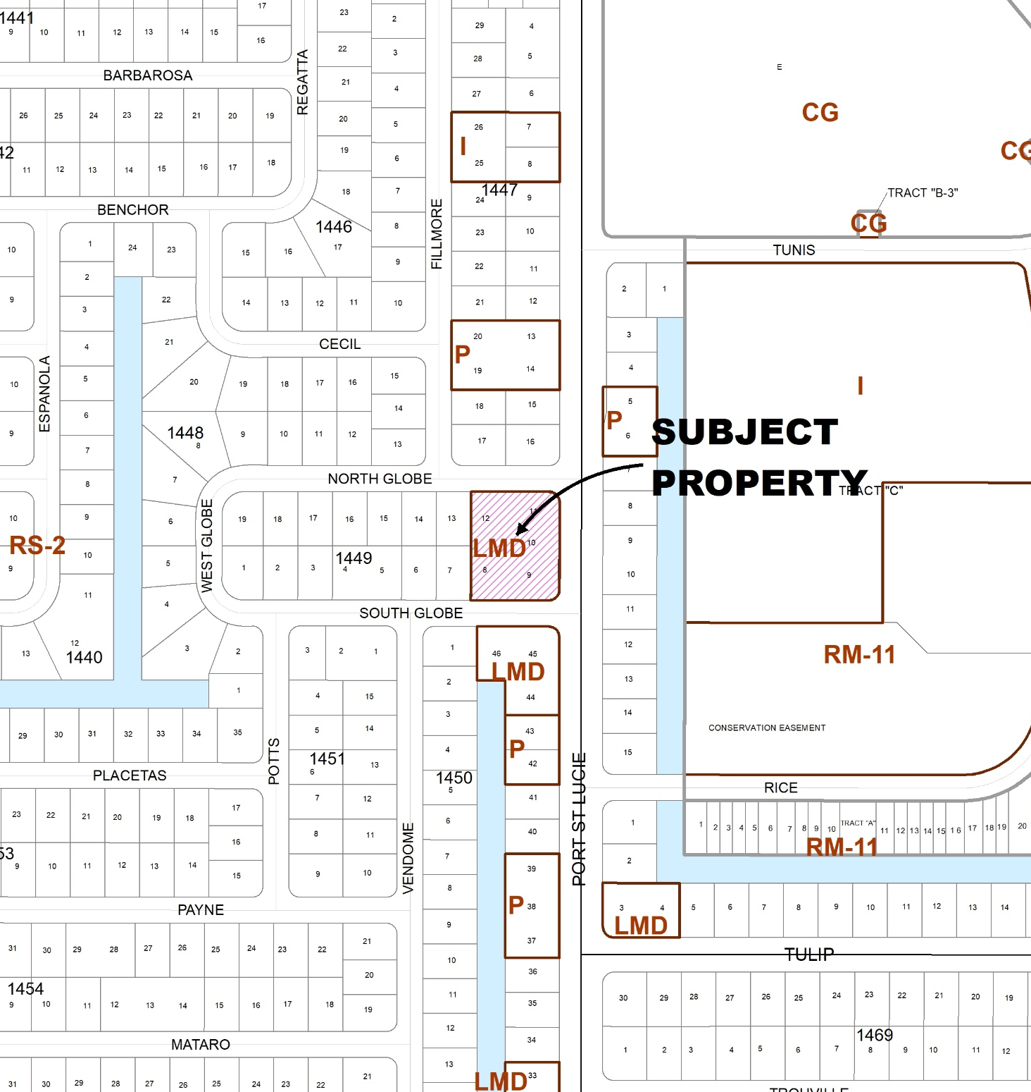
Zoning Map

IMPACTS AND FINDINGS
COMPREHENSIVE PLAN REVIEW
Land Use Consistency: The existing zoning designation of the property is consistent with Policy 1.1.4.13 of the Future Land Use Element which establishes the compatible future land use and zoning categories. The Limited Mixed Use (LMD) zoning district is listed as a compatible zoning district under the Residential, Office, Institutional (ROI) future land use classification.
FUTURE LAND USE CLASSIFICATION | COMPATIBLE ZONING DISTRICT(S)
ROI (Residential, Office, Institutional) | P, I, LMD, RM-5 or Residential PUD (Planned Unit Development) between 5-11 units per acre

ZONING REVIEW
Justification Statement: The purpose of this request is to rezone the parcel for a 13-unit townhome development which aligns with the proposed use, direction, and intent of the Limited Mixed Use Zoning District within the City of Port St. Lucie’s Comprehensive Plan.
Staff Analysis: The applicant’s proposal to reconfigure the subject property’s conceptual plan is consistent with the direction and intent of the City of Port St. Lucie Comprehensive Plan and Zoning Code. Per Section 158.155(P) of the Zoning Code (M), any changes to the conceptual plan and/or changes to the proposed uses, is subject to the hearing requirements for rezoning as designated in the Zoning Code. The proposed use of a 13-unit multifamily townhome development is a permitted use and density within the LMD zoning district, as stated in Section 158.155(C)(2). The applicant has provided preliminary building elevations and a landscape plan per Section 155(M)(1) of the Zoning Code. The building elevations and landscape plans are attached.

STAFF RECOMMENDATION

The Planning and Zoning Department staff finds the request to be consistent with the direction and intent of the future land use map and policies of the City's Comprehensive Plan and recommends approval.
Planning and Zoning Board Action Options:
- Motion to recommend approval to the City Council
- Motion to recommend denial to the City Council

Please note: Should the Board need further clarification or information from either the applicant and/or staff, it may exercise the right to table or continue the hearing or review to a future meeting.

